Post Lab Questions and Tables of Lab 3:
- Define energy.
Energy is the ability or capacity to do work or cause a change.
In simple words: If something can move, heat, light, or change anything, it has energy.
Measured in joules (J)
Cannot be created or destroyed (only changes form) — this is called the Law of Conservation of Energy
Exists in many forms
Common Types of Energy:
Kinetic Energy → energy of motion (moving car)
Potential Energy → stored energy (water in a dam)
Electrical Energy → used in circuits
Thermal Energy → heat
Example:
A battery stores energy → gives electrical energy → lights a bulb
2. Define power.
Power is the rate at which work is done or energy is transferred over time.
In electrical circuits, power is given by:
$$P=VI$$
where P is power, V is voltage, and I is current.
3. What is charge?
Charge is a fundamental property of matter that causes it to experience a force in an electric field.
It is measured in coulombs (C) and can be positive or negative.
4. What is circuit?
A circuit is a closed path through which electric current flows.
It consists of components like a power source, wires, and electrical devices.
5. What is the role of a resistor in the series circuit?
In a series circuit, a resistor limits the flow of current and helps divide voltage among components.
It also protects devices from excessive current.
6. What is the voltage divider rule?
The voltage divider rule states that in a series circuit, the total voltage is divided among resistors in proportion to their resistance.
Formula:
$$V_{n = \frac{R_{n} }{R_{total }}} x V_{total}$$
7. What are the features of the series circuit?
Same current flows through all components
Total resistance is the sum of all resistances
Voltage divides across components
If one component fails, the entire circuit stops working
8. Differentiate between the internal circuit of voltmeter and ammeter.
Voltmeter: Has very high resistance and is connected in parallel
Ammeter: Has very low resistance and is connected in series
9. In which combination do we connect DMM to measure current and voltages?
To measure current, the DMM is connected in series
To measure voltage, the DMM is connected in parallel

Tables:
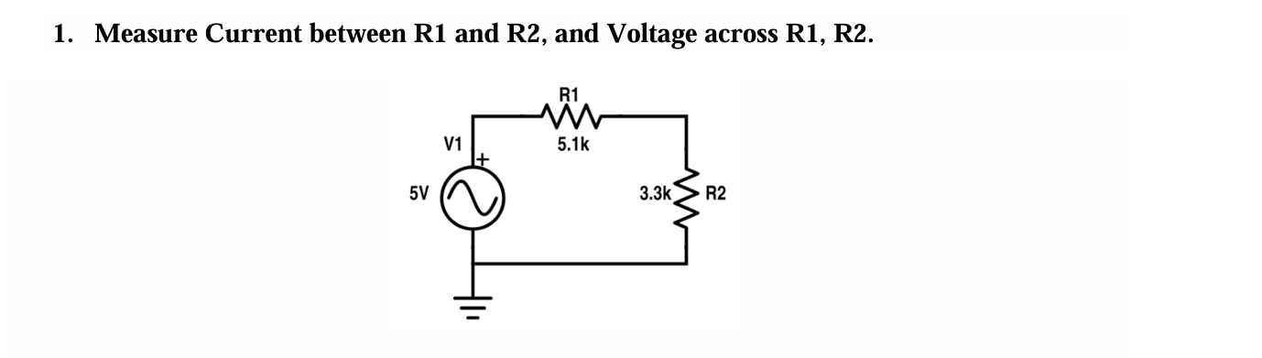
Circuit 1 Tables
Practical Values:
R1 Voltage | R2 Voltage | Current
2.14V | 1.39V | 0.42mA

Theoretical Values:
R1 Voltage | R2 Voltage | Current
3.03V | 1.96V | 0.595mA

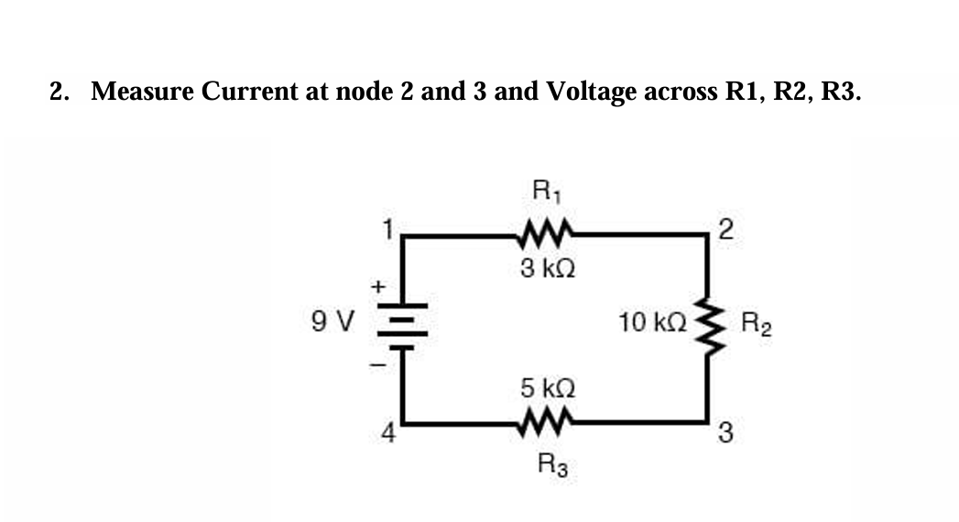

Circuit 2 Tables
Practical Values:
R1 Voltage | R2 Voltage | R3 Voltage | Current at N 2 | Current at N 3
1.5V | 5V | 2.5V | 0.5mA | 0.5mA

Theoretical Values:
R1 Voltage | R2 Voltage | R3 Voltage | Current at N 2 | Current at N 3
1.5V | 5V | 2.5V | 0.5mA | 0.5mA

